1. **Will the following code jump to the label named Target?**

**Mov ax, 81**

**cmp AX, 26h**

**jg Target**

**Ans:** Yes, it will jump

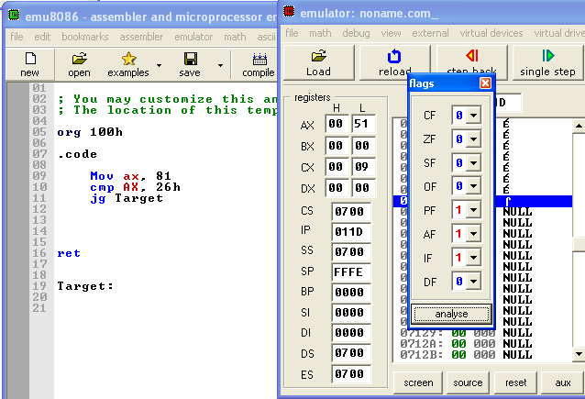

In this code destination > source which mean ZF=0,CF=0. Above window shows this.

1. **Will the following code jump to the label named Target?**

**Mov ax,-30**

**cmp ax,-50**

**jg Target**

**Ans:** Yes, it will jump

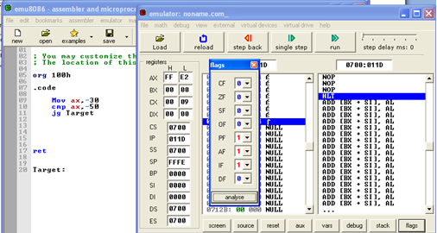

In this code destination > source which mean ZF=0,CF=0. Above window shows this.

1. **Will the following code jump to the label named Target?**

**Mov ax,-42**

**cmp aX,26**

**ja Target**

**Ans:** Yes, the code jump to the label named Target.

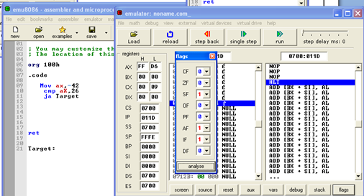

In this code destination > source which mean ZF=0,CF=0. Above window shows this.

1. Write a program to add first ten numbers. The result should be stored in register bl.

Ans:

; You may customize this and other start-up templates;

; The location of this template is c:\emu8086\inc\0_com_template.txt

org 100h

v1 dw 0

code segment

mov bl,0

mov cx, 10

mov ax, 0

L1:

add ax, cx

loop L1

mov bl, ah

mov dx, ax

mov ah, 2h

int 21h

ret 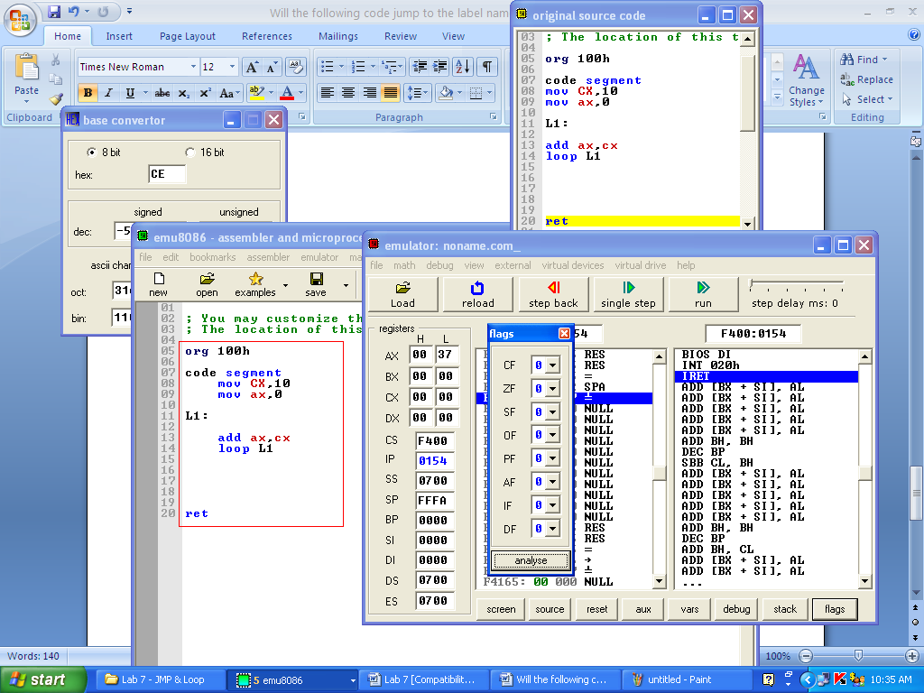

1. **Consider the following data:**

**List1: 10, 20, 30**

**List2: C2, D4, E5**

**Write a program that first calculates sum of list1 and then list2. Store results on different registers.**

**Ans:**

; You may customize this and other start-up templates;

; The location of this template is c:\emu8086\inc\0_com_template.txt

org 100h

.data

v1 dw 0

List1 db 10,20,30

List2 dw 00C2h,00D4h,00E5h

.code

Mov di, offset List1

Mov cx, 3

Mov ax, 0

L1:

add al, [di]

inc di

Loop L1

mov bx, ax

Mov di, offset List2

Mov cx, 3

Mov ax, 0

L2:

add ax, [di]

;inc di

add di, 2

Loop L2

ret

